CENWP-ODT-F 13 January 2022

MEMORANDUM FOR THE RECORD

Subject: DRAFT minutes for the 13 January 2022FPOM meeting. The meeting was held via WebEx from 0900 to 1221 hours. In attendance:

|  |  |  |  |
| --- | --- | --- | --- |
| **Last** | **First** | **Agency** | **Email** |
| Baus | Doug | NWD RCC | [Douglas.m.Baus@usace.army.mil](mailto:Douglas.m.Baus@usace.army.mil) |
| Bettin | Scott | BPA | [swbettin@bpa.gov](mailto:swbettin@bpa.gov) |
| Brandtner | Christine | NWP-FFU | christine.m.brandtner@usace.army.mil |
| Cates | Becca | NWP-BON | rebecca.i.cates@usace.army.mil |
| Conder | Trevor | NOAA | Trevor.Conder@noaa.gov |
| Cooper | Erin | FPC | ecooper@fpc.org |
| Cordie | Robert | NWP-TDA | [Robert.P.Cordie@usace.army.mil](mailto:Robert.P.Cordie@usace.army.mil) |
| Cousins | Katherine | NWS | Katherine.L.Cousins@usace.army.mil |
| Derugin | Andrew | NWP-BON | Andrew.G.Derugin@usace.army.mil |
| Ebel | Jonathan | IDFG | Jonathan.Ebel@idfg.idaho.gov |
| Edwards | John | WDFW – Sea lions | john.edwards@dfw.wa.gov |
| Fielding | Scott | NWP JDA | Scott.D.Fielding@usace.army.mil |
| Grosvenor | Eric | NWP-JDA | [Eric.Grosvenor@usace.army.mil](mailto:Eric.Grosvenor@usace.army.mil) |
| Hausmann | Ben | BPA Predation | bjhausmann@bpa.gov |
| Hesse | Jay | Nez Perce Tribe | jayh@nezperce.org |
| Holdren | Elizabeth | NWW-LGR | Elizabeth.A.Holdren@usace.army.mil |
| Lorz | Tom | CTUIR | lort@critfc.org |
| Macdonald | Jacob | NWP | Jacob.Macdonald@usace.army.mil |
| Mackey | Tammy | NWP | Tammy.m.mackey@usace.army.mil |
| Madson | Patricia | NWP-FFU | Patricia.L.Madson@usace.army.mil |
| Martinson | Rick | PSMFC | Rickdm@gorge.net |
| McClain | Nathan | NWP | Nathan.A.McClain@usace.army.mil |
| ~~McDowell*~~ | ~~Michelle~~ | ~~USFWS~~ | [~~Michelle_McDowell@fws.gov~~](mailto:Michelle_McDowell@fws.gov) |
| Morrill | Charlie | WDFW | [Charles.Morrill@dfw.wa.gov](mailto:Charles.Morrill@dfw.wa.gov) |
| Mrozek | Kallan | NWP-HDC-C | kallan.k.mrozek@usace.army.mil |
| Mumma | Mitchel | USBR | All, please email me contact info -Nathan |
| Peery | Chris | NWW | Christopher.A.Peery@usace.army.mil |
| Peterson | Christine | BPA | [chpetersen@bpa.gov](mailto:chpetersen@bpa.gov) |
| Porter | Laurie | CRITFC | [porl@critfic.org](mailto:porl@critfic.org) |
| Silver | Greg | CRITFC | gsilver@critfc.org |
| Skiles | Tom | CRITFC | skit@critfc.org |
| St. John | Scott | NWW | Scott.j.st.john@usace.army.mil |
| Storch | Adam |  |  |
| Sullivan | Leah | BPA | lssullivan@bpa.gov |
| Swank | David | USFWS | David_Swank@fws.gov |
| Thompson | Josie | NOAA | Josie.Thompson@noaa.gov |
| Van Dyke | Eric | ODFW | [erick.s.vandyke@state.or.us](mailto:erick.s.vandyke@state.or.us) |
| Warf | Don | PSMFC | dwarf@psmfc.org |
| Wendler | Jeanette | NWP BON | Jeanette.C.Wendler@usace.army.mil |
| Wertheimer | Bob | NWP-FFU | [Robert.h.wertheimer@usace.army.mil](mailto:Robert.h.wertheimer@usace.army.mil) |
| Whitney | Don |  | All, please email me contact info -Nathan |
| Wright | Lisa | NWD-RCC | [Lisa.S.Wright@usace.army.mil](mailto:Lisa.S.Wright@usace.army.mil) |

*Called in for the Avian Updates only

1. **Final decisions or recommendations made at this meeting.**
   1. Approve November Meeting Minutes with WDFW edits? Approved
   2. Approve December Meeting Minutes? Approved
2. **Action Items** 
   1. **NWW** 
      1. **[November 21]** 21 LMN 06 MOC North Fish Ladder Debris Barrier Anchor Block.ACTION ITEM: Peery will see if concrete pumping could be delayed. *Update: work was completed later in the morning. Could not move to late afternoon. Did not appear to impact fish passage.*
      2. **[December 21]** ICE South fish ladder temp monitor broken, cannot calculate the differential. ACTION ITEM: Peery will update progress next FPOM. *Update: Parts on hand will be in place by early spring.*
   2. **NWP**
      1. **[July 21] WA AWEP status update.ACTION:** Morrill will report back on the progress. *Update: Going to internal review nearly complete, going to next stage this month.*
      2. **[December 21]** **NWP/NWW Critical Fish Passage O&M needs.** ACTION**:** Mackey will host separate meeting after the January FPOM. *Update: Moved to stand-alone meeting, might follow a short FPAC.*
   3. **Completed Action Items or to be discussed later in the agenda**
      1. **[October 21]** **JFF Early Starts.** FPOM requested Peery put together a list of locations and dates for early start so they can make recommendations. Peery will also add a table of previous early starts. Information was sent out.
      2. **[November 21]** **Inland Avian.** ACTION: Mackey will check with NWP PME group about the best forum for a Columbia Basin avian group. Tom Skiles (CRITFC) is working on a group to share information on avian activity beyond the dams.
      3. **[December 21] ODFW John Day River Overshoot active tag study.** ACTION: McClain will add this to January’s agenda. *UPDATE: Added to end of Research Updates.*
      4. ACTION Item: Elizabeth and Peery with write up the MFR detailing Corps operations including IDFG field reports. *Update: 22 DWR 01 MFR Dworshak Ops Dec 21 & 27 emailed to FPOM 1/18/22*
3. **Updates**
   1. **NWW Updates**
      1. JFF Early Start – MCN 1 March, LGR 24th or 25 March, others 1 April.
      2. SMP will not be at LoMo Working with BPA as they plan to cover the labor gap needed for condition monitoring at LoMo. Looking at two people. They still believe they can get contractor on. Morrill asked about permitting. Will be adding LoMo to the existing Ice Harbor permit. St. John working with NOAA to get application in. Likely to request less take when compared to SMP operations. Morrill will work with Sean Rath (EAS) on the WA state permit.
      3. Upcoming maintenance/construction/research activities (previously coordinated MOC/MFRs).
         1. 20 LGS 16 MOC Powerhouse Roof Repair – April start date would be difficult for BPA to make. Looking at flows and snowpack (currently higher than typical) so may plan work for July
         2. 21 LGS 13 MOC Guidewall Anchor Cables Replacement – Dive work is on schedule.
         3. 21 LWG 08 MOC Trash Rake Crane Replacement (May 2022) – Still planned for May. Van Dyke asked about length of time? Work should take a few days.
         4. LWG Adult Trap Water Supply – Waiting for input on potential to change water supply. Conder, due to abrupt temperature changes I think we can take this off the agenda.
         5. MCN spillway crane repairs. Spill patterns for underrated cranes and TSW removal (21 MCN06 Modified spill pattern for TSW removal). Crane 6 in operation, crane 7 is out. Motor is on site to get crane 7 back up and running. Hoist on spillbay 6 may have a broken gear – an engineer is inspecting. Checking to see
         6. Dworshak Dam mortality event (0930) –Email from Eble on the 23rd about dead fish below Dworshak. Don Whitney (IDFG) confirmed seeing ~30 dead fish in the tailrace. Conversation continued about the timing of operations. Elizabeth will check with John to confirm. Hess is concerned that we don’t have a clear description of the operations and reasons for them to help prevent mortalities in the future. Don Whitney returned call from concerned angler about a bunch of dead Stealhead on the 23rd (from voicemail on the 22nd). Don drove to the tailrace and observed 30 fish, likely Steelhead, in the shallows. Also saw some live fish swim by with head injuries, but they were difficult to see due to distance, up to 100 yards to the corner where some dead fish were floating belly up. Previous creel surveys found one Coho with the remainder all Steelhead. Van Dyke asked if previously developed switching procedures were followed to prevent fish mortlaity. Elizabeth confirmed that procedures where followed. Security footage was viewed during this time period but they did not see any fish mortalities.

ROV draft tube inspection of Unit 3 (Elizabeth) – surprised to find flow even though unit was shut down. Did find three or four decomposing dead fish. Found another dead fish about 30 feet downstream. Unit 2 was running and seemed to be the origin of the flow. She will be there on the 19th when Unit 3 starts up. Will take video prior to start up, looking down and an observer will be at the wall where fish tend to eddy out. There will also be a boat in the water.

Conder disagrees of Corps evaluation that mortalities were, “. . . very unlikely caused by starting and stopping of Units” Fish have been observed with fresh head wounds and given the timing seems like we should look closer. This is in the BiOp item and if there is still a problem, we would move to exclusion screens. Conder requests an MFR to document this event. Peery agrees, there is a one to three minute period of time between the air burst and speed no-load where fish could swim in. Uncertain of the water level and the Francis wheel turbine but there might be potential that the airburst itself is forcing fish into the turbine blades. Peery did not want to send out an MFR based on second or third had information. Hess asked if there was a way to solidify the commitment to minimize the starting and stopping of units. Peery and Elizabeth will reach out to the project to see how much capacity there is to minimize starts/stops. Bettin asked to keep BPA in the loop as trade offs are discussed. Hess stressed these moralities are unacceptable to the Nez Perce tribe. Discussion about load shaping (turning turbines off and on) may have to take place at a higher level such as RE OG. Sport fishers harvested ~1700 Steelhead from the north fork.

ACTION Item: Elizabeth and Peery with write up the MFR detailing Corps operations including IDFG field reports. *Update: 22 DWR 01 MFR Dworshak Ops Dec 21 & 27 emailed to FPOM 1/18/22*

* 1. **BPA update**
     1. **Flow Table Updates** (Jim Alders BPA 11:00) **–** As part of the grid modernization effort to ensure turbine controls were functioning properly and tables correctly represented the energy output. Jim and John Patla walked through a slide show detailing the difference between gross head and the lesser net head value due to friction from the intake and draft tube. Conder expressed concern about pulling more water through the turbine, given the new 1% curves. May not be a problem at The Dalles but would require closer coordination for changes at Bonneville PH2 due to potential for gatewell injury. If they see a 1% operations that would result in high turbine flow, they will reach out prior to implementing. (ended 11:31 / 2:44:30)
  2. **ODFW’s John Day River Overshoot Active Tag study presentation** (Ian Tattam 11:30 to 12:00) 2020-21 run years, Migration Patterns of Adult Steelhead, They Vemco acoustically + PIT tagged 200 Wild A-index steelhead at the BON AFF. Cordie asked if there were differences in behavior between fish passing JD N or JD S? No difference. Swank asked about straying rate and relationship to transport. We are now transporting much fewer fish. pHOS declined to near zero in 2019, 2020 and 2021. This slide show is posted to the FPOM website.
  3. **NWP Updates**
     1. Upcoming maintenance/construction/research activities (previously coordinated MOC/MFRs).
        1. 21BON001 MOC Navigation Lock 1 (old navlock) Bridge Replacement scheduled for CY 2023**.**
        2. 21BON097 MOC Early STS Removal – completed as planned.
        3. 19TDA04 MOC Crane rail Replacement winter (on going work) – working on correcting the clearance issue they discovered on the west end.
        4. 20TDA10 MOC PUD Smolt Bypass Extended Outage – work is in progress.
        5. 18JDA02 MOC Trash rack replacement. Scheduled for April 2022. -No update
        6. 20JDA04 MOC STS crane replacement. -No update
     2. BON Aqui-S long term solution. -Corps internal meeting next week.
     3. TDA AWS debris management. (Rerecich FC, Medhi Rashani TL, Kovalchuck temp PM) – still awaiting funding.
     4. TDA trunnion pin. Via email from Michael S. Colesar, on 1/28/2021 “Gate 9 trunnion would be part of a larger project to completely rehab Gates 1-9. SAP shows Start in 2031, Construction 2034”
     5. JDA north pump #4. -No update
     6. JDA spill bay 10. In manual operation, have not figured out remote operations from the control room, likely manual most of spill season. – Engineers visited to look at the controls.
     7. JDA N elevator #4 -Contractor is on site, waiting to get a fix it quote.
     8. JDA SMF April start up
  4. **NWS (Seattle)**
     1. Upcoming maintenance/construction/research activities (previously coordinated MOC/MFRs).
     2. Albeni Falls Dam -No updates at this time.
     3. Chief Joseph Dam
     4. Libby Dam
  5. **Research/FFDRWG updates.** <http://pweb.crohms.org/tmt/documents/FPOM/2010/FFDRWG/FFDRWG.html>
     1. **NWP FFDRWG.** BI site visit today.
     2. **NWW FFDRWG.**  Next meeting 19th, noon start time. Agenda forthcoming.
  6. **RCC update**

|  |  |  |  |  |
| --- | --- | --- | --- | --- |
| **Project** | **Previous Day Average Outflow (kcfs)** | **5 Day Forecasted Inflow (kcfs)** | **10 Day Forecasted Inflow (kcfs)** | **Forecasted Inflow Low/High (kcfs)** |
| **LWG** | 25 | 27 | 27 | 26 (1/14) / 29 (1/13) |
| **MCN** | 167 | 161 | 178 | 148 (1/18) / 185 (1/15) |
| **BON** | 176 | 180 | 188 | 160 (1/18) / 197 (1/16) |

**Table 1. NOAA Northwest River Forecast Center inflow forecast.**

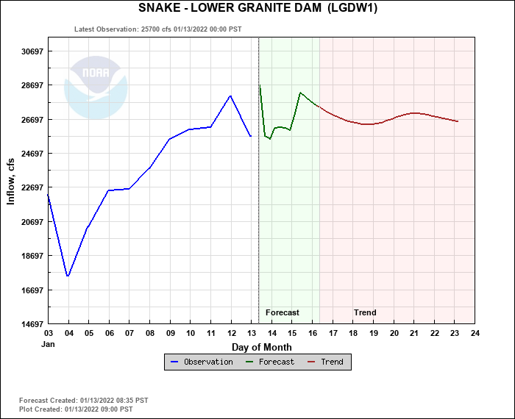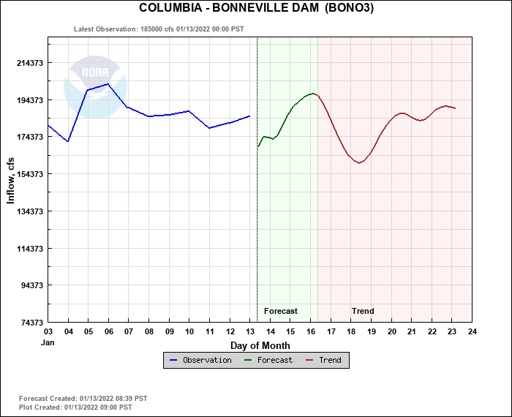

* 1. **Fish Count Program update (Peery, Wertheimer) –** Only counting at Bonneville right now, until the end of the winter maintenance period when ladders start coming back up. February/March.
  2. **Pinniped update** 
     1. Bonneville Dam – less than 5 animals at the dam. Annual Report hopefully by February.
     2. Willamette Falls – no update
  3. **Lamprey update** 
     1. BON – Jake Macdonald and Accords/FFDRWG site visit today Bradford Island. Orifice cutting BI serpentine weir section moving forward. B-Branch LPS & WA Shore serpentine rebuild PDTs moving forward.
     2. TDA – PDT working on design options for E ladder junction pool LPS & entrance weir slot plating.
     3. JDA – PDT working on gravity feed for N ladder LPS/trap hope to install this time next winter. S ladder trap – working on grating to prevent debris buildup.
     4. NWW – Turbine cooling water intake will be discussed at FFDRWG.
     5. Lamprey Accords Work Group (Macdonald) – Several lamprey presentations at the recent AFEP, no further update.
  4. **Avian updates (10:30)**
     1. NWW – Inland Avian Management Plan update (Anderson or Peery) – Is there some low cost dissuasion we could deploy at Bader Island? May move brush that is on the island to cover nesting area. Call with USFW refuge manager.
     2. JDA – Typical number of birds for January. Gulls, grebes, and even one pelican.
     3. TDA – Typical numbers and the eagles have shown up. Cordie shared graph showing trend of increasing bird numbers from 2015 – 2021. Specifically gulls from a daily mean counts from 4/1 to 7/21 increasing from 77 (2015) TO 166 (2021)
     4. BON – Typical number for this time of year.
     5. Estuary – Tidwell asked for USFWS (McDowell) how much time she would need to comment on FFU reports. Swank will forward request to McDowell. Lorz asked if predation analysis is going forward this year? The Corps has sewn tags and detected them from the colony at the end of the season but is not obligated to estimate predation rates every year. Krasnow asked about the potential to PIT tag
     6. Lethal Removal – Update of the NEPA progress (Schmidt) – Schmidt’s out of office states he is at the coast for an emergency involving the South Jetty.

1. **NWP/NWW Critical Fish Passage O&M needs (Mackey will host stand alone meeting)**
2. **Coordination/Notification forms (need concurrence/discussion)**
   1. 21 IHR 15 MOC Unit 2 special generator testing. FPOM concurred with this work.
3. **Fish Passage Plan** 
   1. The 2021 FPP is in effect through February 28, 2022.
   2. The DRAFT 2022 FPP is in development. Draft sections and Change Forms are at: [pweb.crohms.org/tmt/documents/fpp/2022/changes](http://pweb.crohms.org/tmt/documents/fpp/2022/changes/)
      1. 2022 FPP production schedule:

* 27-JAN-2022: Annual FPOM FPP meeting.
* 11-FEB-2022: drop dead due date for all approved and finalized language.
* 22-FEB-2022: Final 2022 FPP posted online.
* 1-MAR-2022: Final 2022 FPP goes into effect.

1. **Task Group Updates.**
   1. Task Group Avian meeting (Cordie) -No update
      1. <http://pweb.crohms.org/tmt/documents/FPOM/2010/Task%20Groups/Task%20Group%20Avian%20Hazing/>
   2. Task Group Condition Monitoring (Lorz & Sullivan) -Waiting on comment for JD change form.
      1. <http://pweb.crohms.org/tmt/documents/FPOM/2010/Task%20Groups/Task%20Group%20Condition%20Monitoring/>
   3. Task Group 15 Mile Steelhead Overshoots, TDA ITS operation dates. (Bellerud) Meeting invite has been sent to group.
      1. <http://pweb.crohms.org/tmt/documents/FPOM/2010/Task%20Groups/Task%20Group%20TDA%20ITS%20operations/>
   4. Task GroupNon-native Piscine Predation (Thompson).
      1. <http://pweb.crohms.org/tmt/documents/FPOM/2010/Task%20Groups/Task%20Group%20Non-native%20piscivorous%20fish>

From the Chat: from Josie Thompson to everyone: 11:35 AM

Hello all, I have to run to an appointment. As far as the Piscine Predation Team updates go.... Blaine Parker is working on the white paper, and the plan is to potentially have a draft to discuss at our next meeting, which will ideally occur after the February FPOM meeting. We do not have a meeting scheduled for today.

Meeting ended at 1221 hours.